实验编号： 11 **四川师大《IOS》实验报告 2018** 年 **11** 月 **21** 日

### **计算机科学学院** 2016 级 4 班 实验名称： 多MVC _

姓名：__邹琳__ 学号：__2016110458_ 指导老师：__李贵洋__ 实验成绩:_____

**实验 十一 ____**多MVC **_______**

1. 实验目的及要求
2. 掌握多MVC的设计以及实现；
3. 完成苹果官网的FoodTracker全部内容；
4. 实验要求
5. 认真填写实验报告，要求附加部分运行界面和主要代码；
6. 对设计好的程序，检查输出是否符合预期，如有错请分析错误原因并解决；
7. 实验内容
8. 实现一个简单的多mvc程序
   1. 控制器之间正向传参
   2. 控制器之间反向传参
9. 完成苹果官网的FoodTracker Demo（多MVC）
   1. TableView（自定制Cell）；
   2. NavigationController；
   3. Modal Controller;
   4. ImagePickerController;

说明：苹果官网Demo网址如下

<https://developer.apple.com/library/content/referencelibrary/GettingStarted/DevelopiOSAppsSwift/index.html>

1. 实验主要流程、基本操作或核心代码、算法片段（该部分如不够填写，请另加附页）
2. 实现一个简单的多mvc程序
   1. 控制器之间正向传参
   2. 控制器之间反向传参

程序代码：

//

// ViewController.swift

// 11-1(mvc)

//

// Created by student on 2018/12/5.

// Copyright © 2018年 zoulin. All rights reserved.

//

import UIKit

//2

//protocol StudentProtocol {

// func change(name:String,no:String)

//}

class FirstViewController: UIViewController {

var stu = Student()

//2

// func change(name: String, no: String) {

// self.name = name

// self.no = no

// }

// var name = ""

// var no = ""

@IBOutlet weak var tfNo: UITextField!

@IBOutlet weak var tfName: UITextField!

override func viewDidLoad() {

super.viewDidLoad()

// Do any additional setup after loading the view, typically from a nib.

}

override func viewWillAppear(_ animated: Bool) {

tfNo.text = stu.no

tfName.text = stu.name

}

@IBAction func showSecondVc(_ sender: Any) {

stu.no = tfNo.text!

stu.name = tfName.text!

let secVC = UIStoryboard(name: "Main", bundle: nil).instantiateViewController(withIdentifier: "SecondVC") as! SecondViewController

secVC.stu = stu

//2

// secVC.delegate = self

// self.present(secVC, animated: true, completion: nil)

self.navigationController?.pushViewController(secVC, animated: true)

}

@IBAction func showThirdVC(_ sender: Any) {

let thirdVC = UIStoryboard(name: "Main", bundle: nil).instantiateViewController(withIdentifier: "ThirdVC")

self.present(thirdVC, animated: true, completion: nil)

}

}

/******************************************************************/

//

// SecondViewController.swift

// 11-1(mvc)

//

// Created by student on 2018/12/5.

// Copyright © 2018年 zoulin. All rights reserved.

//

import UIKit

class SecondViewController: UIViewController {

var stu:Student!

//2

//var delegate: StudentProtocol?

@IBOutlet weak var tfNo: UITextField!

@IBOutlet weak var tfName: UITextField!

override func viewDidLoad() {

super.viewDidLoad()

tfNo.text = stu.no

tfName.text = stu.name

// Do any additional setup after loading the view.

}

@IBAction func back(_ sender: Any) {

stu.no = tfNo.text!

stu.name = tfName.text!

//

// delegate?.change(name: name, no: no)

//1

// for vc in self.navigationController!.viewControllers {

// if let firstVC = vc as? FirstViewController{

// firstVC.no = no

// firstVC.name = name

// }

// }

// dismiss(animated: true, completion: nil)

navigationController?.popViewController(animated: true)

}

/*

// MARK: - Navigation

// In a storyboard-based application, you will often want to do a little preparation before navigation

override func prepare(for segue: UIStoryboardSegue, sender: Any?) {

// Get the new view controller using segue.destination.

// Pass the selected object to the new view controller.

}

*/

}

/****************************************************************/

//

// ThirdViewController.swift

// 11-1(mvc)

//

// Created by student on 2018/12/5.

// Copyright © 2018年 zoulin. All rights reserved.

//

import UIKit

class ThirdViewController: UIViewController {

override func viewDidLoad() {

super.viewDidLoad()

// Do any additional setup after loading the view.

}

@IBAction func close(_ sender: Any) {

dismiss(animated: true, completion: nil)

}

/*

// MARK: - Navigation

// In a storyboard-based application, you will often want to do a little preparation before navigation

override func prepare(for segue: UIStoryboardSegue, sender: Any?) {

// Get the new view controller using segue.destination.

// Pass the selected object to the new view controller.

}

*/

}

/********************************************************************/

// Student.swift

// 11-1(mvc)

//

// Created by student on 2018/12/8.

// Copyright © 2018年 xudongting. All rights reserved.

//

import Foundation

class Student{

var name = ""

var no = ""

}

运行结果：

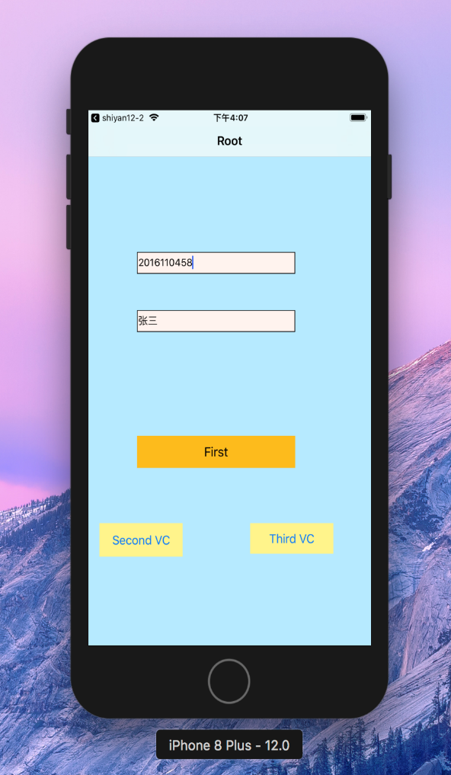 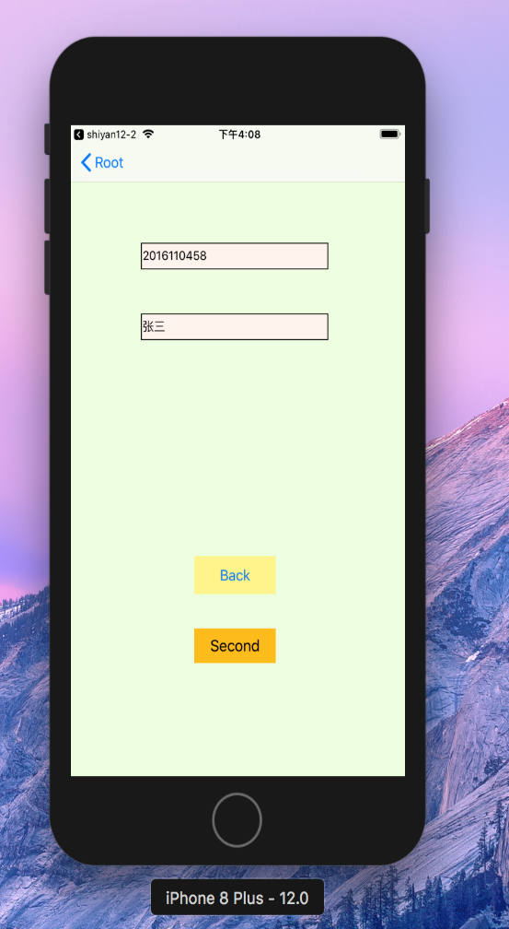 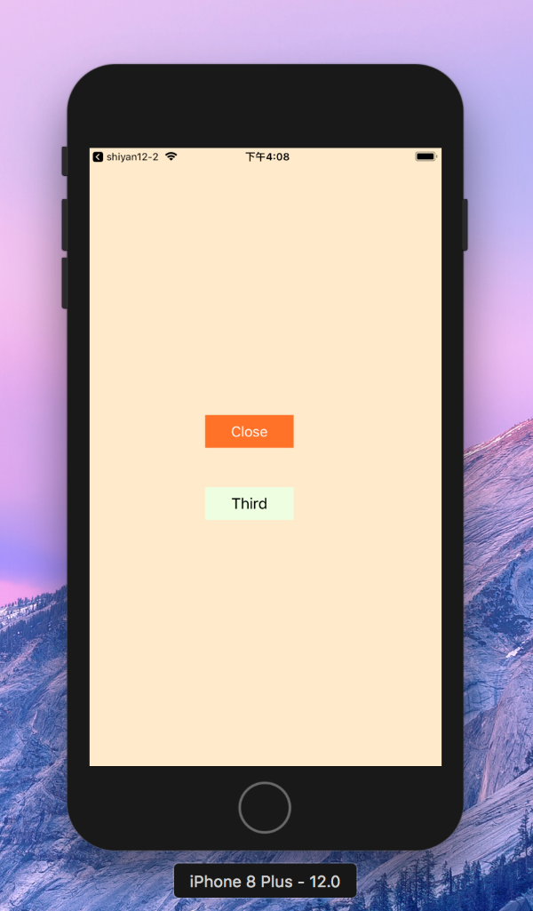

1. 完成苹果官网的FoodTracker Demo（多MVC）
   1. TableView（自定制Cell）；
   2. NavigationController；
   3. Modal Controller;
   4. ImagePickerController;

说明：苹果官网Demo网址如下

<https://developer.apple.com/library/content/referencelibrary/GettingStarted/DevelopiOSAppsSwift/index.html>

程序代码：github上

运行结果：

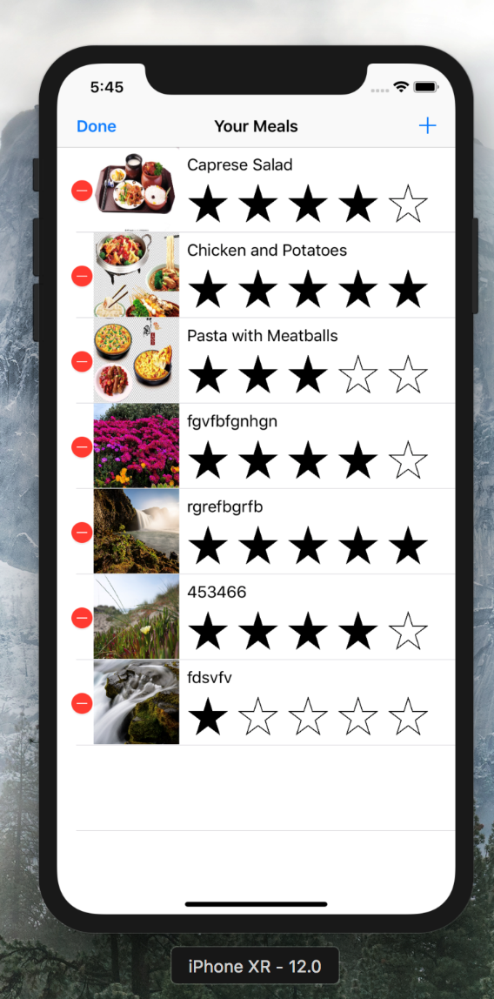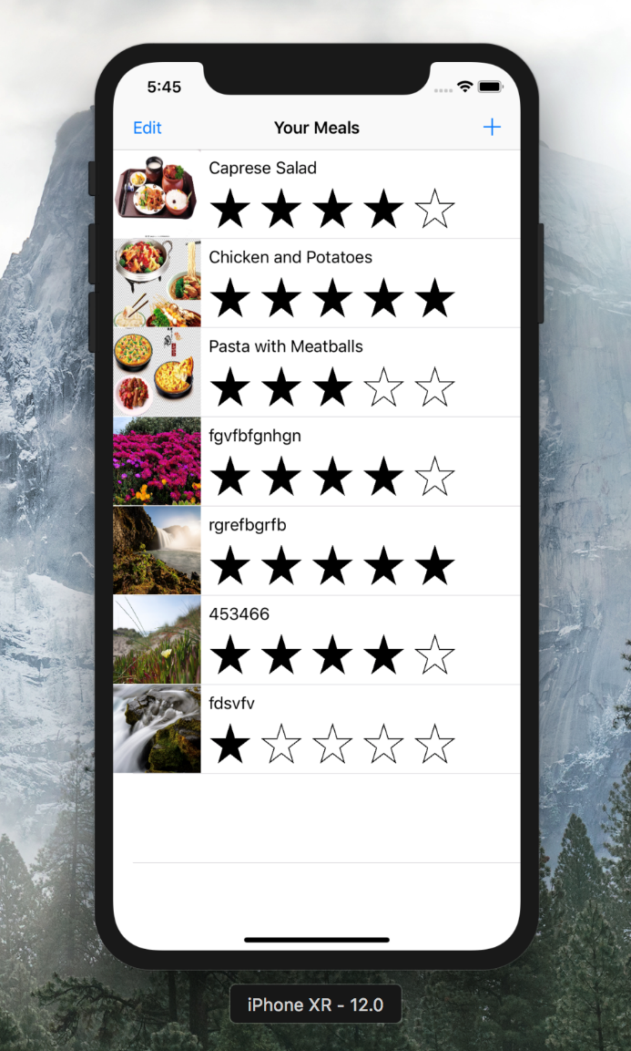

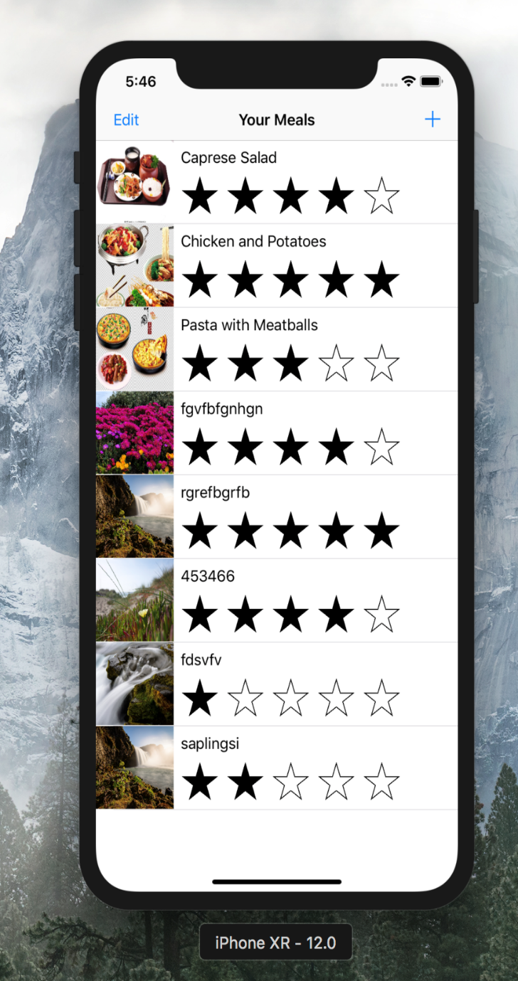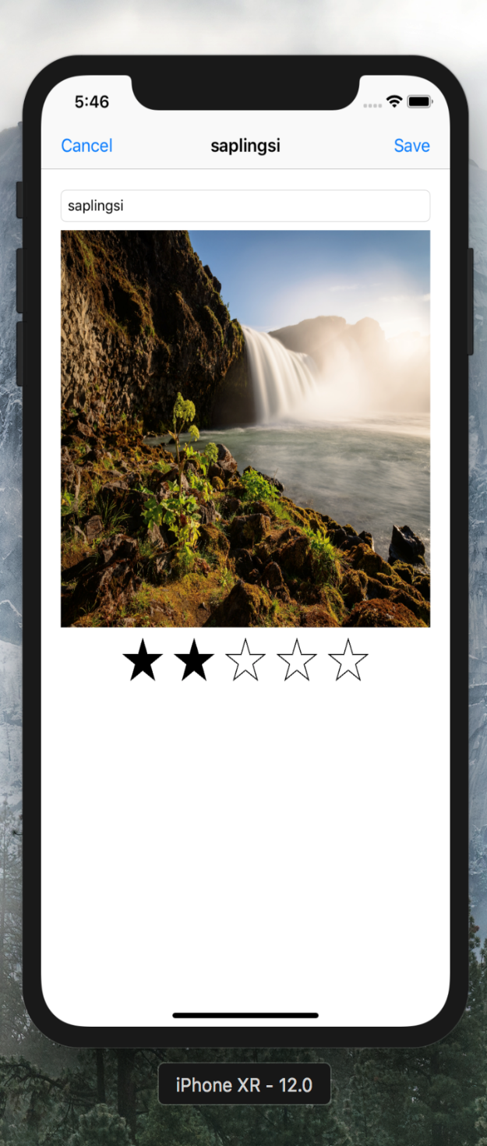

1. 实验结果的分析与评价（该部分如不够填写，请另加附页）

Github地址：

注：实验成绩等级分为（90－100分）优，（80－89分）良，(70-79分)中，（60－69分）及格，（59分）不及格。